Digital Logic Design

QUIZ#4

Section B

Roll#-------------------------------

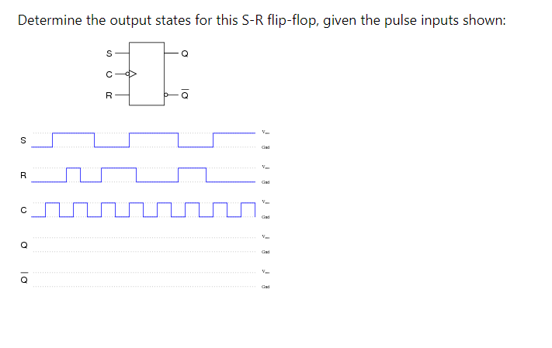

Solution:

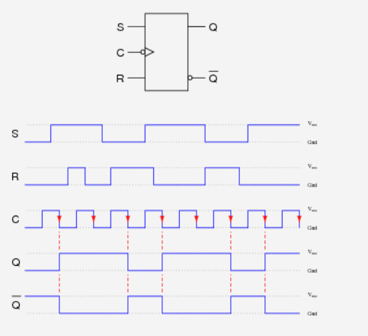

Q2. (5 Marks)

1. Make a Characteristic Table and write down characteristic equation for SR Flip Flop. (2)
2. Make SR flip flop using D Flip Flop? (3)

Solution:

1. Make k map and find equation for Q(n+1)

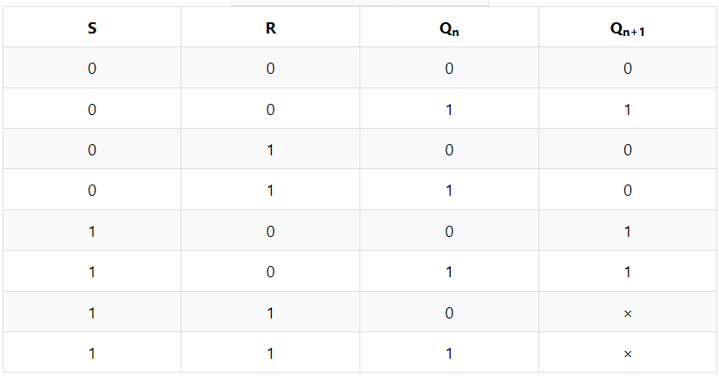

b) 